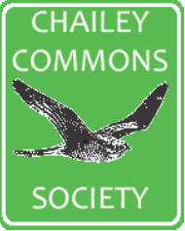
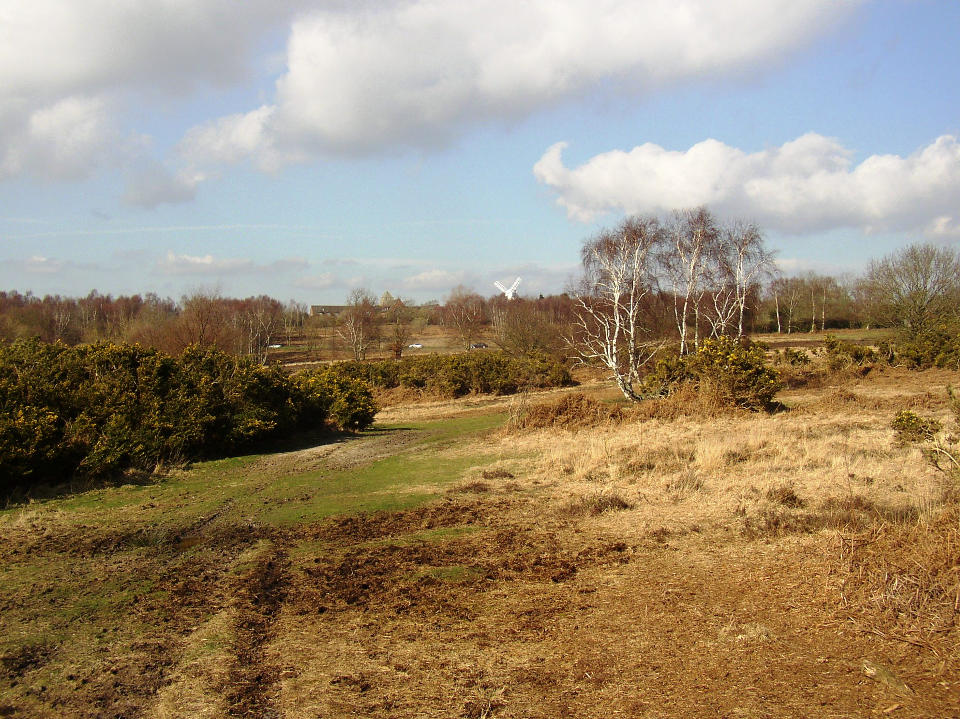

October

Thursday October 8th Indoor Meeting - Talk
7.30.p.m. Rich. Allum Grazing Officer
Chailey Village Hall BN8 4BE CONSERVATION GRAZING
Ashdown Forest

Friday October 16th Outdoor Meeting 10.00a.m. - 12.15.p.m. Fungus Walk - £5 charge
Red House Common BN8 4JE with Martin Allison
Meet at car park
BOOKING ESSENTIAL

Sunday October 18th Outdoor Meeting
08.00.a.m. – 10.00.a.m. Bird Walk with Adrian
Red House Common BN8 4JE Meet at car park

November

Thursday November 12th Indoor Meeting - Talk
7.30.p.m. Graeme Lyons
Pan Species Listing
Chailey Village Hall BN8 4BE Introducing his new book

Outdoor Meetings – Information and bookings to ‘members@chaileycommons.org.uk’ or 01444 831098

CHAILEY COMMONS SOCIETY
ACTIVITIES DIARY
October - December 2026

